UNIT TITTLE.MOBILE APPLICATION DEVELOPMENT
UNIT CODE:BIT 4107

COMPILED BY: ELIAPH GITHANJI WAWERU
BIT/2024/53616

PROJECT NAME: MYKEJA
APPLICATION USED: ANDROID STUDIO
LANGUAGE USED: KOTLIN
LECTURER NAME: MR MICHAEL NYORO

Introduction to the project
Finding a decent place to live in Kenya—whether it’s a bedsitter, a one-bedroom, or an apartment can be an absolute headache. Between dodging fake online listings, dealing with pushy, unregistered brokers who charge viewing fees for non-existent houses, and doing endless physical legwork, the process is exhausting.
The MyKeja app was built specifically to solve these exact frustrations. It is a digital real estate marketplace designed to bridge the gap between property seekers, landlords, and verified agents in Kenya.

Project Objectives
- Eliminate Physical Fatigue. To replace the exhausting process of door-to-door searching by creating a centralized, searchable database of available properties accessible anytime from a smartphone.
- Establish Trust and Security: To eradicate rental scams and fraudulent "brokers" through strict property verification, secure communication channels, and identity checks for agents.
- Deliver Personalized Matching: To allow users to pinpoint their ideal home instantly using advanced filtering systems (budget, layout, proximity to work/school, and specific amenities like borehole water, high-speed internet, or parking).
4. Provide True Visual Transparency: To ensure users see the actual state of a house through high-definition photos, video walk-throughs, or 3D virtual tours, eliminating the disappointment of "expectation vs. reality" upon arrival.

Installation Steps
How to download Android Studio
- Open your web browser and navigate to the official developer portal: developer.android.com/studio.
- Click the prominent "Download Android Studio" button.
- Accept the Google Terms and Conditions checkbox to initiate the download.

Steps for installation
• Double-click the downloaded executable file (usually named android-studio-xxxx-windows.exe).
• If a User Account Control (UAC) prompt pops up asking for permission, click Yes.
• In the Setup Wizard, click Next.
• Choose Components: Ensure both Android Studio and Android Virtual Device (AVD) are checked, then click Next.
• Choose your preferred installation location (the default path in C:\Program Files\Android\Android Studio) and click Next.
• Click Install. Once the progress bar fills up, click Next and then Finish to launch Android Studio.
THE SCREENS BELOW SHOW THE STEPS DURING ISTALLATION;

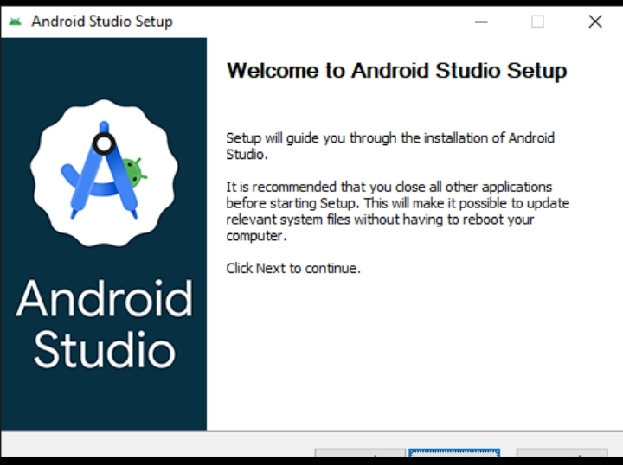
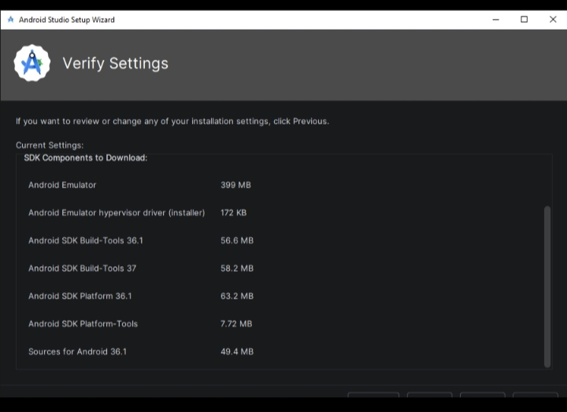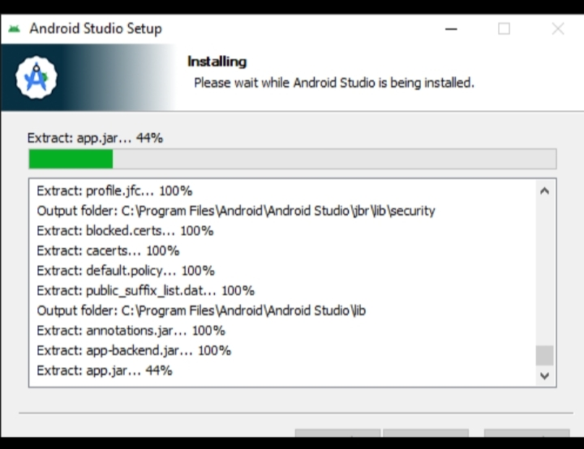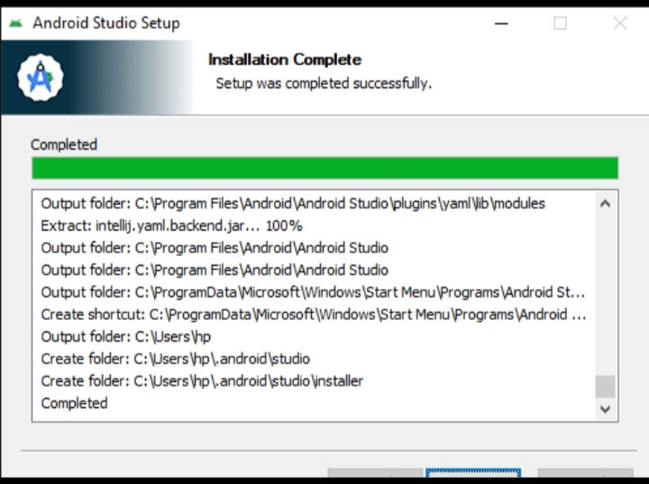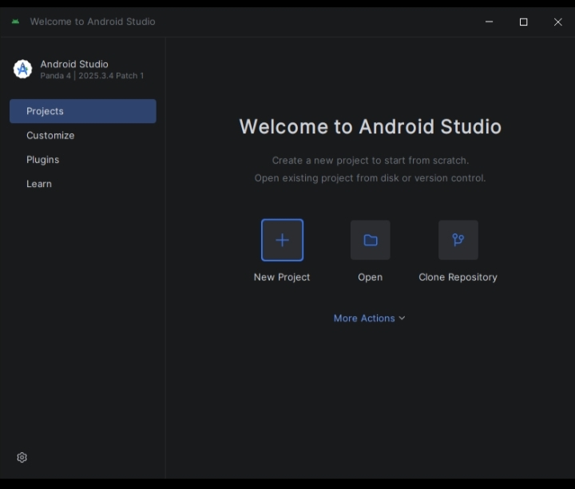
Weekly Objectives
.1.Precision filtering which allows users to search for the house according to their budget, location ,amenities and property size
2.Integrating maps to display neighborhood amenities such as schools, hospitals and roads
3. Time saving previews which will save users physical trip through professional photography and virtual or augmented reality
4.Listing verification which will reduce fraud and deceit by providing verified badges and community star ratings for landlords and properties
5.Payment management which will help to provide a centralized platform to process and track ongoing utility bills, deposits and rent.

Challenges Encountered
- Installing the visual android studio requires a larger RAM of more than 8GB
- The app development process takes lots of time

